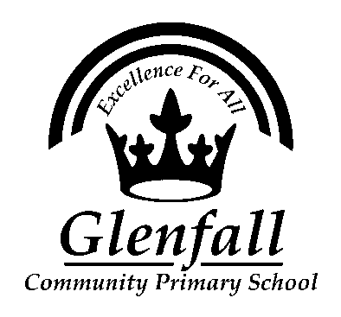

Glenfall Community Primary School
Admissions Policy

Date Agreed by Governors March 2017

Date of Review March 2020
School Admissions Statement
Glenfall Community Primary School adopts the Local Authority Admissions Policy. A copy of this policy can be found on the Local Authority website: http://www.gloucestershire.gov.uk/education-and-learning/school-admissions-scheme-criteria-and-protocol/determined-admission-criteria-and-scheme-for-2017/

Starting school in Reception (Foundation Stage)
If you wish your child to start school at Glenfall you will need to follow the procedures detailed on the Gloucestershire County Council website: http://www.gloucestershire.gov.uk/education-and-learning/school-admissions/apply-for-a-primary-or-infant-school-place/
There is an online application system that is usually open from mid-November to mid-January with places being offered in April before the new school year. Exact dates will vary so please follow the information given on the website.

In Year Admissions
‘In Year’ admissions refer to children starting at Glenfall at a time other than the start of their Reception year (foundation stage).
Information about this process is available from http://www.gloucestershire.gov.uk/education-and-learning/school-admissions/applying-for-a-school-place-during-the-school-year/
If you are interested in your child moving to Glenfall, please first contactthe school office on 01242 234055 to enquire if we have places available in the year group that you are seeking.
If we have places available and you wish to apply for your child, you will need to complete an application form available from the county council’s website (see above) and then email it to us on admin@glenfall.gloucs.sch.uk.

