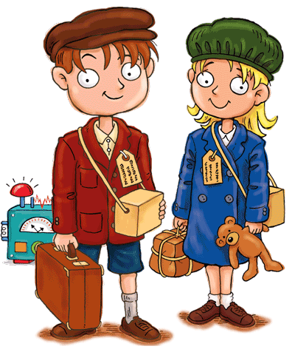

**SCIENCE**

Humans and animals

Testing viscosity

The circulatory system

William Harvey

The effects of drugs and alcohol on the body

Healthy eating

**ENGLISH**

Poetry

Adventure stories

Character descriptions

Diary writing

Grammar and vocabulary

**MATHS**

Place value

Mental and written calculations

2D and 3D shape

Angles

Problem solving

**HISTORY**

Key events

The Blitz

Rationing

Evacuation

Air Raids

Anne Frank

World War Two Christmas

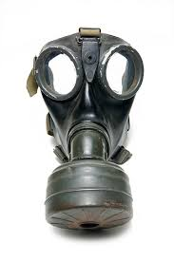

**FRENCH**

Classroom routines

Clothes

Family

**ART**

Chalk pictures

Caricatures

Propaganda posters

**PSHE**

Taking responsibility

New beginnings

Philosophy for children

Debating

**Battle of Britain**

**Music**

Composing

Performing

Reading musical notes

**DT**

Cooking rationing recipes

Making and testing out air raid shelters

**ICT**

* E-safety
* Coding.

**PE**

Dance

Football

**RE**

Creation stories and science