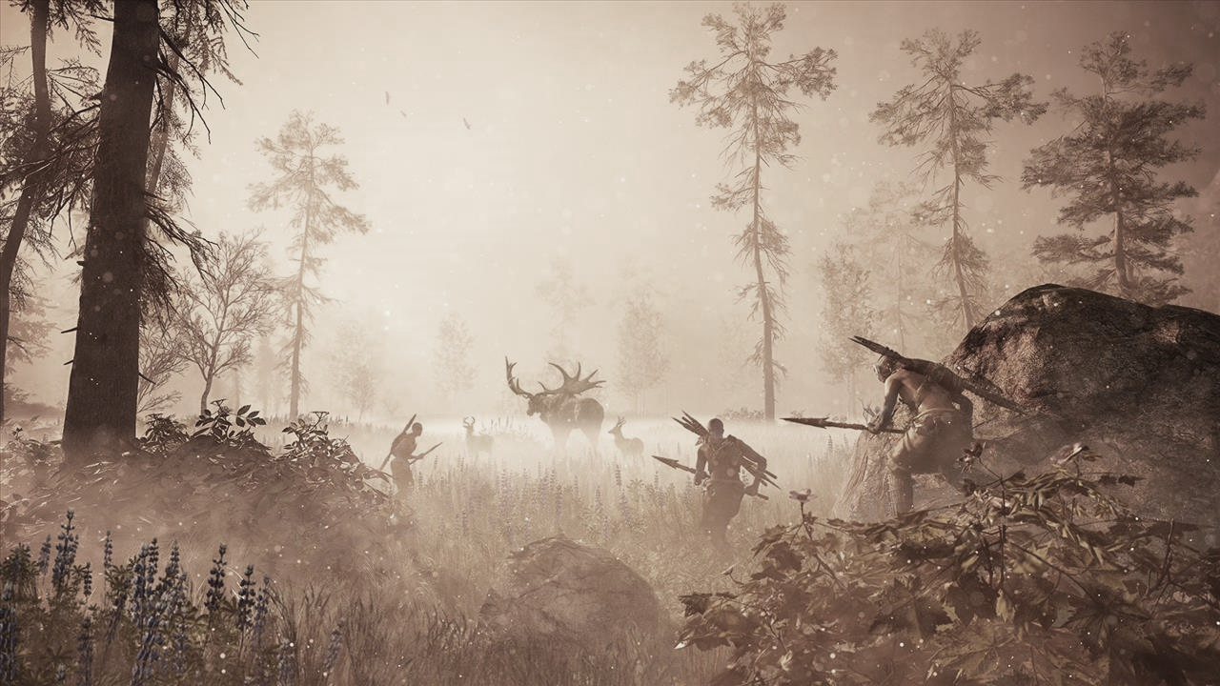

PE

Field games – tag rugby and football

Dance

THE STONE AGE

DT

Design and make an outfit from recycled materials

ICT

SCRATCH – a programme designed to develop programming skills

Music

Exploring rhythmic patterns

Exploring arrangements

Art

Use of colour mixing, origami dinosaurs, 3d models, simple weaving, cave paintings

RE

Sacred texts, Why the Bible is important to Christians

French

Colours, healthy and unhealthy foods and greetings

History

Timelines, reporting on Stone Age creatures, Stonehenge, Bronze Age, Iron Age tribes

Science

Rocks and soils, investigating soil samples, classifying types of rocks, testing for permeability and hardness