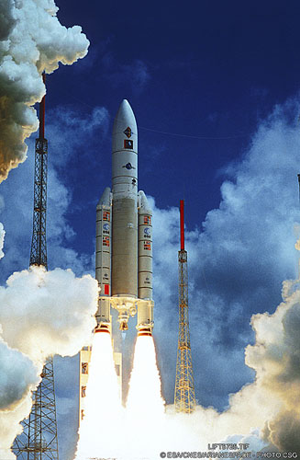
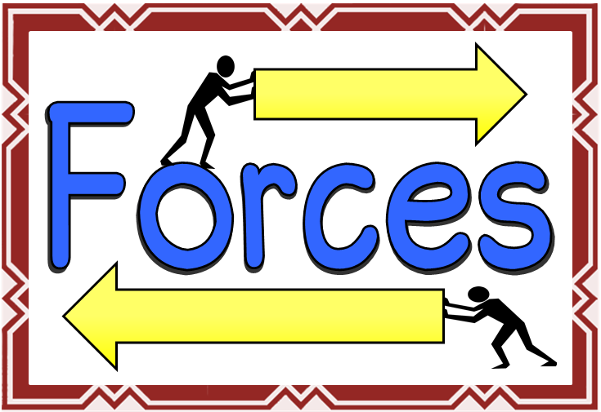

ENGLISH
Letters
Stories: character and setting
Explanations Précis
Argument/ debate

MATHS
Fractions – adding and subtracting
Write decimals as fractions
Percentages
Length, capacity and mass
3D and 2D shape

THE EARTH IN SPACE
- Our solar system
- Measuring forces
- Balanced and unbalanced forces
- Friction
- Air-resistance
- Water resistance
- Heliocentric and geocentric models
- Day and night
- Earth’s tilt and seasons
- The moon
BLAST-OFF
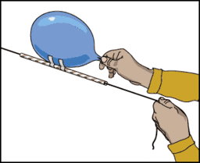
Music - Space Composition
RE - Why do Christians believe Jesus is the Messiah?

Art/DT
Peter Thorpe – space artist
Space buggies
Use of different media to create sketches of planets and aliens

FRENCH
Parts of the body, food, hobbies, likes and dislikes, Easter in France
ICT –Logo and spreadsheets
PSHE – Keeping Safe
HISTORY/GEOGRAPHY
History of space travel
Atlas skills
Black holes, constellations, moon exploration
PE
Gymnastics
Dance

