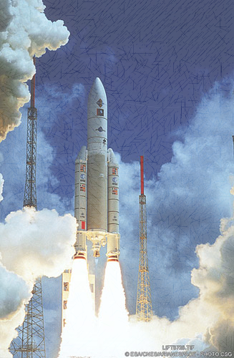

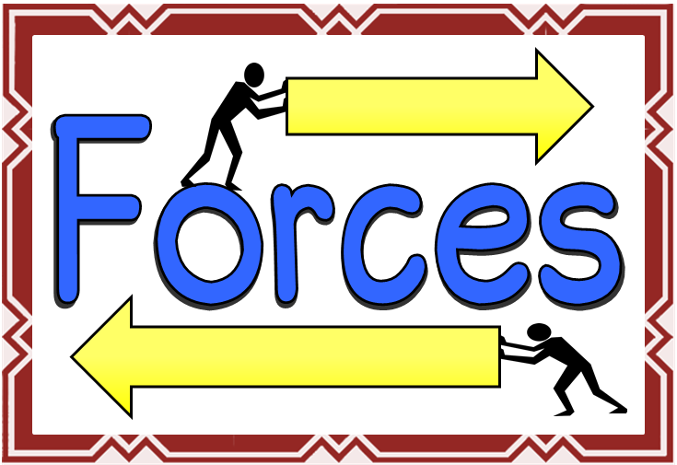

**ENGLISH**

Poetry

Journalistic Writing

Mystery stories

Argument/ debate

Spelling and Grammar

**MATHS**

2D and 3D Shape

Area and perimeter

Algebra

Fractions, decimals and Percentages

Number work

**THE EARTH IN SPACE**

* Our solar system
* Measuring forces
* Balanced and unbalanced forces
* Friction
* Air-resistance
* Water resistance
* Heliocentric and geocentric models
* Day and night
* Earth’s tilt and seasons
* The moon

PE

* Hockey
* Tag rugby

**BLAST-OFF**

DT/Art

Make a controllable space vehicle

Space painting and collage

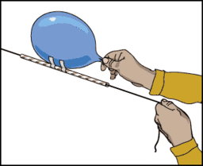

ICT

* Scratch software
* QR codes

French

Food

Hobbies

Easter

PSHE/ philosophy for children

* Making choices
* Justifying your decisions
* Keeping safe

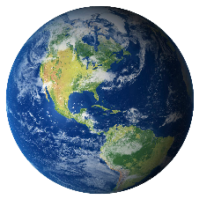

Geography

* Map work
* Physical an human features

RE

* Why do some people believe in God and some not?