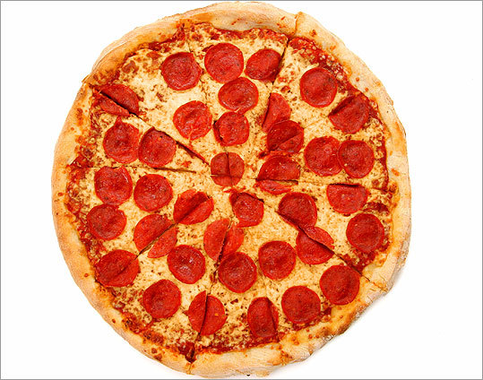

Viva Italia

**Art**

**Roman shields**

**Modigliani**

**Mosaics**

**History**

**Roman invasion**

**Pompeii**

**Roman food, entertainment and beliefs**

**Roman villas and baths**

**Music**

**Percussion**

**Exploring signals**

**Performance**

**Pe**

**Cricket**

**Athletics – running, jumping and throwing**

**Re**

**Where, how and why do Christians worship?**

**Computing**

**Pattern images**

**Control work**

**Animation**

**Excel**

**Science**

**Solid, liquid and gas**

**Melting, dissolving and freezing**

**The water cycle**

**Mfl**

**Zoo animals**

**Body parts**

**To the doctors**

**Family**

**Dt**

**Making pizzas**

**Structures**

**sowing**

**Geography**

**Italian Geography**

**Map Skills**

**Volcanoes**