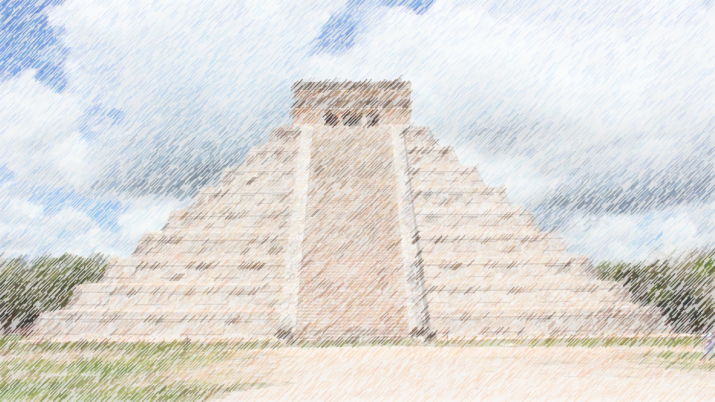

Art

Mayan art – mosaics

Music

Exploring sound

This term Year 3 and 4 will be focusing their studies around the topic of the Mayans. This theme will flow throughout their learning both in school and in their homework.

**AZTECS**

Year 3 & 4

Autumn term 2018

Topic

Mayan life and South American geography

PE

Football

Swimming (Y3)

Science

Light and sound with links to multiculturalism and RE

ICT

Internet search engines and Scratch coding

DT

Nativity sculpture and South American food

RE

Festival of lights