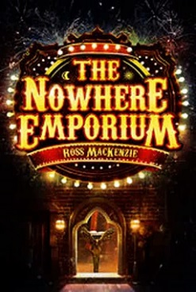

**Geography**

* Map and atlas skills
* Longitude and latitude
* Comparing physical and human features
* Identifying key cities, rivers and mountains in the UK

**PE**

* Netball and tag rugby
* Gymnastics
* Creating a sequence individually and in pairs
* Using apparatus safely

**Literacy**

* Grammar including conjunctions and tense.
* Punctuation including apostrophes, dashes, semi-colons, colons, commas and brackets
* Character and setting descriptions
* Adventure stories
* Biographies and autobiographies

**French**

* Days of the week
* Classroom instructions
* Speaking in sentences

**ICT**

* Research
* Using scratch programme
* Coding

**Maths**

* Fractions, decimals and percentages
* Algebra
* Measures, including time
* Sequences
* Problem solving
* Number fluency

**Art and DT**

* Sketching
* 3D collage
* Constructing a photo frame
* Planning and evaluating

**RE**

* Why do some people believe in God and some people don’t?

**PSHE**

* Healthy and unhealthy relationships
* Behaviours that affect our feelings
* Acts of kindness
* Expressing our opinions (P4C)

**Science**

* Evolution of plants
* Evolution of animals
* Theories of evolution
* Survival of the fittest
* Famous scientists – Mary Anning and Charles Darwin.

**Fantastic Journeys**