c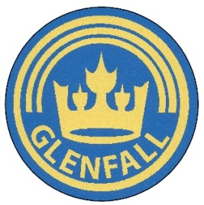

Glenfall Curriculum Topic Overview

Year 1

Subject | Autumn Term 1 | Autumn Term 2 | Spring Term 1 | Spring Term 2 | Summer Term 1 | Summer Term 2
Topic titles | Once upon a time | Let there be Light! | Toy Box | Transport | India | Pirates & Treasure Island
History | Famous children’s authors through time | Bonfire Night  Remembrance ay  Florence Nightingale | Development of toys through time | Local History  Jet Age museum- Gloucester |  | Significant pirates
Geography | Daily weather chart  Town Mouse and Country Mouse | Daily weather chart | Daily weather chart  Using geographical vocabulary | Daily weather chart | Daily weather chart | Daily weather chart  Treasure maps  Compass directions, locational and directional language
Science | Everyday materials and their properties  Transparency investigation | Senses  Body Parts investigation | Animals including humans  Carnivore/Herbivore/Omnivore investigation | Animals including humans  Animal Classification investigation | Plants  Plants and seasonal changes investigation | Plants  Leaf Look investigation
Art | Character masks | Fireworks  Mondrian  Clay diva lamps | Still life portraits of toys  Imaginative toy pictures |  | Rangoli mehndi patterns
DT |  | Pop-up Christmas cards | Moving images | Moving vehicles | Cookery: Making chapatis
PSHE | New beginnings  Roles and responsibilities | Anti-bullying week | Making choices (including drug education) | Keeping safe | Feelings and relationships | Making healthy choices  PANTS Talk
RE | What does it mean to belong to a faith community? | What do Christians believe God is like? | Who is Jewish and how do they live? | Who do Christians say made the world? | How should we care for the world and others, and why does it matter?
COMPUTING |  | Drag and drop | Digital images | Word processing  (punctuation) | Coding  Moving robot | Digital writing
MUSIC | Using the ‘Sing Up’ Scheme of Work for Year 1

