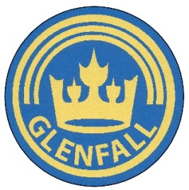

Glenfall Curriculum Overview
Year 2

Subject | Autumn Term 1 | Autumn Term 2 | Spring Term 1 | Spring Term 2 | Summer Term 1 | Summer Term 2
Topic | Toy Story | Let’s Celebrate! | The Great Fire of London | Kings and Queens | Africa | My Island Home
History | Neil Armstrong and other great explorers | Guy Fawkes  WWI Remembrance | The Great Fire of London | Famous Kings and Queens
Geography | Aerial photographs, mapping etc of school grounds |  | Map of London showing how the fire spread |  | Countries, capitals and seas of UK  Continents and oceans  Comparing Cheltenham to town in Africa | Geographical vocabulary to compare Charlton Kings with the Isle of Coll  Mapping skills  Physical and human features
Science | Everyday materials and their properties  Materials hunt investigation | Animals including humans  Rocket Mice investigation | Animals including humans  Hand span investigation | Living things and their habitats  Sorting living and non-living things investigation | Plants  Plant growth investigation | Uses of everyday materials  Waterproof investigation
Art |  | Firework pictures Poppies | Colour mixing  Fire pictures | Royal portraits  King/Queen sketching | African patterns | Tartan weaving  Andy Goldsworthy-natural and manmade materials
DT | Hand puppets - sewing |  | Tudor house with working door
PSHE | New beginnings  Roles and responsibilities | Anti-bullying week | Making choices (including drug education) | Keeping safe | Feelings and relationships | Making healthy choices
RE | Who is Muslim and how do they live? | Why does Christmas matter to Christians? | Who is Muslim and how do they live? | Why does Easter matter to Christians? | What is the ‘good news’ Christians believe that Jesus bring? | What makes some places sacred to believers?
Computing | IT around us |  | Creating digital media |  |  | E-safety  Programming floor robots
MUSIC | Using the ‘Sing Up’ Scheme of Work for Year 2

