Music Curriculum Progression

Music Curriculum Intent:

At Glenfall all children experience a wealth of musical opportunities to create, participate and perform both individually and as part of a whole class ensemble. They will learn and appreciate music from around the world and develop a lifelong love for the subject. Children will have an opportunity can learn a musical instrument as well as have multiple opportunities to sing and play classroom instruments. Through actively participating in interactive sessions, they will grow in confidence and develop their individual musicality.

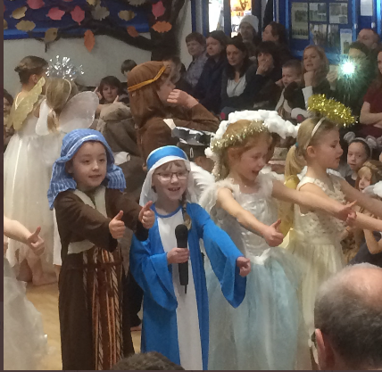
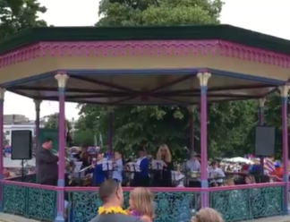
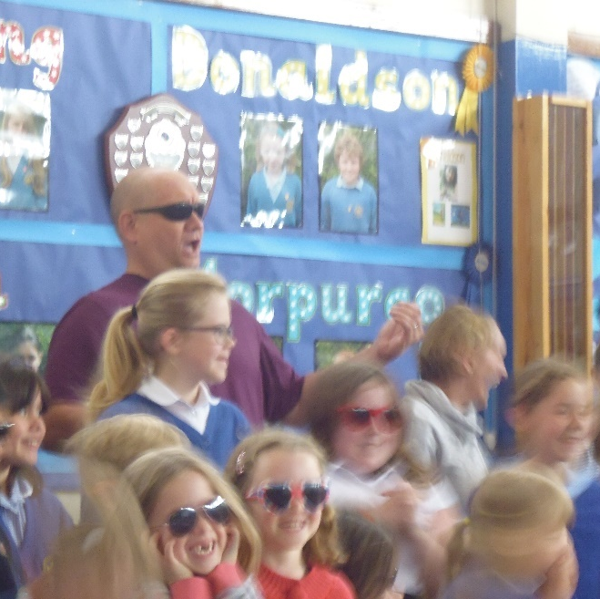

Implementation
Music Curriculum Progression EYFS – Year 2

 | EYFS | Year 1 | Year 2
Use of voice expressively and creatively | - Sing echo songs and perform movements to a steady beat.  - Explore singing at different speeds and pitch to create moods and feelings.  - Discover how to use the voice to create loud and soft sounds. | - Explore the use of the voice in different ways such as speaking, singing and chanting.  - Discover how the voice can produce rhythm and pulse, high and low (pitch) to create different effects.  - Find out how to sing with expression, confidence, and creativity to an audience. | - Sing with a sense of the shape of a melody.  - To represent sounds with symbols.  - To improvise in making sounds with the voice.  - Perform songs using creativity and expression and create dramatic effect.
Play tuned and untuned instruments | - Play instruments to a steady beat.  - Understand how to hold and play an instrument with care.  - Explore the different sounds instruments make.  - Choose an instrument to create a specific sound. | - Play instruments showing an awareness of others.  - Repeat and investigate simple beats and rhythms.  - Learn to play sounds linking with symbols.  - Understand how to play an instrument with care and attention | - Perform simple patterns and accompaniments keeping to a steady pulse.  - Recognise and explore how sounds can be organised.  - Respond to starting points that have been given.  - Understand how to control playing a musical instrument so that they sound, as they should.
Listen with concentration and understanding | - Express feelings in music by responding to different moods I a musical score.  - Listen to music and respond by using hand and whole-body movements.  - Listen to different sounds (animal noise, water etc…) and respond with voice and movement. | - Choose sounds to represent different things (ideas, thoughts, feelings, moods etc.).  - Reflect on music and say how it makes people feel, act and move.  - Respond to different composers and discuss different genres of music. | - Notice how music can be used to create different moods and effects and to communicate ideas.  - Listen and understand how to improve own composition.  - Sort composers into different genres and instruments into different types.
Experiment with, create, select and combine sounds | - Choose different instruments, including the voice, to create sound effects in play.  - Investigate a variety of ways to create sound with different materials.  - Experiment performing songs and music together with body movements to a steady beat. | - Create a sequence of long and short sounds with help, including clapping longer rhythms.  - Investigate making sounds that are very different (loud and quiet, high and low etc.).  - Explore own ideas and change as desired. | - Choose carefully and order sounds in a beginning, middle and end.  - Use sounds to achieve an effect (including use of ICT)  - Create short musical patterns. Investigate long and short sounds.  - Explore changes in pitch to communicate an idea.

Music Curriculum Progression KS2
 | Year 3 | Year 4 | Year 5 | Year 6
Play and Perform | - Sing in tune.  - Perform simple melodic and rhythmic parts.  - Improvise repeated patterns.  - Beginning to understand the importance of pronouncing the words in a song well.  - Start to show control in voice.  - Perform with confidence. | - Sing in tune with awareness of others.  - Perform simple melodic and rhythmic parts with awareness of others.  - Improvise repeated patterns growing in sophistication.  - Sing songs from memory with accurate pitch.  - Maintain a simple part within a group.  - Understand the importance of pronouncing the words in a song well.  - Show control in voice.  - Play notes on instruments with care so they sound clear.  - Perform with control and awareness of what others in the group are singing or playing. | - I create songs with an understanding of the relationship between lyrics and melody.  - Whilst performing by ear and from notations, I maintain my own parts with awareness of how the different parts fit together and the need to achieve an overall effect.  - Breathe well and pronounce words, change pitch and show control in singing.  - Perform songs with an awareness of the meaning of the words.  - Hold a part in a round.  - Perform songs in a way that reflects their meaning and the occasion.  - Sustain a drone or melodic ostinato to accompany singing.  - Play an accompaniment on an instrument (e.g., glockenspiel, bass drum or cymbal). | - Perform significant parts from memory and from notations with awareness of my own contribution.  - Refine and improve my own work.  - Sing or play from memory with confidence, expressively and in tune.  - Perform alone and in a group, displaying a variety of techniques.  - Take turns to lead a group.  - Sing a harmony part confidently and accurately
Develop an understanding of the history of music. | - Describe the different purposes of music throughout history and in other cultures.  - Understand that the sense of occasion affects the performance. | - Understand that the sense of occasion affects the performance.  - Combine sounds expressively | - Understand the different cultural meanings and purposes of music, including contemporary culture.  - Use different venues and occasions to vary my performances. | - Notice and explore how music reflects time, place and culture.  - Understand and express opinions on the different cultural meanings and purposes of music, including contemporary cultural  - Use different venues and occasions to vary my performances.
Improvise and compose music | - To compose music that combines musical elements.  - Carefully choose sounds to achieve an effect.  - Order my sounds to help create an effect.  - Create short musical patterns with long and short sequences and rhythmic phrases. | - Compose music that combines several layers of sound.  - Awareness of the effect of several layers of sound.  - Compose and perform melodies and songs (Including using ICT).  - Use sound to create abstract effects.  - Recognise and create repeated patterns with a range of instruments.  - Create accompaniments for tunes.  - Carefully choose order, combine and control sounds with awareness of their combined effect. | - Use the venue and sense of occasion to create performances that are well appreciated by the audience. Compose by developing ideas within musical structures.  - Improvise melodic and rhythmic phases as part of a group performance.  - Improvise within a group. | - Improvise melodic and rhythmic material within given structures.  - Show thoughtfulness in selecting sounds and structures to convey an idea.  - Create my own musical patterns.  - Use a variety of different musical devices including melody, rhythms, and chords.
Listen with attention to detail and recall sounds. | - To notice and explore the way sounds can be combined and used expressively.  - Listen to different types of composers and musicians. | - To notice, analyse and explore the way sounds can be combined and used expressively.  - To comment on musician’s use of technique to create effect | - Notice and explore the relationship between sounds.  - Notice and explore how music reflects different intentions. | - Notice, comment on and compare the use of musical devices.  - Notice, comment on and compare the relationship between sounds.  - Notice, comment on, compare and explore how music reflects different intentions.
Appreciate and understand a wide range of live and recorded music. | - Begin to recognise and identify instruments being played.  - Comment on likes and dislikes.  - Recognise how musical elements can be used together to compose music. | - Begin to recognise and identify instruments and numbers of instruments and voices being played.  - Compare music and express growing tastes in music.  - Explain how musical elements can be used together to compose music. | - Compare and evaluate different kinds of music using appropriate musical vocabulary.  - Explain and evaluate how musical elements, features and styles can be used together to compose music. | - Analyse and compare musical features choosing appropriate musical vocabulary.  - Explain and evaluate how musical elements, features and styles can be used together to compose music.

Impact on our children when leaving in Year 6:

- Our children will have a wealth of opportunities to experience and explore their musicality through performance both in school and out of it.
- Our children can recognise a range of musical instruments and identify the group they belong to.
- Our children can recognise music from a range of genre and talk about them using the correct terminology.
- Our children can improve their work through improvisation and appraisal.
- Our children can compose their own simple music using both traditional methods and IT.
- Our children can understand basic musical notation, graphic scores and contemporary chord sheets.
- Our children will experience collaborating with professional musicians in community-based projects.
- Our children will grow in confidence as individual musicians and will be encouraged to harbour a love of music.

Assessment

- Performance – class videos of children making progress as young musicians.
- Whole school performances throughout the year including events such as Young Voices, Carol concert and nativities as well as celebrating significant events.
- Curriculum – Progression supported by Sing Up Music Programme with formative ongoing assessment in lessons providing ways to improve and feedback.
- Mind maps using Music vocabulary and pictures, showing individual responses to music. Summative assessment at end of year, using collected evidence throughout the year to give an overall judgement of progress.

