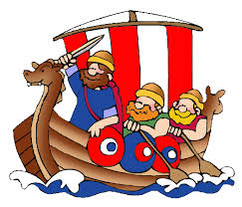
Home Learning for Invaders

Produce one piece of homework for our topic on Invaders. This needs to be completed by Monday 8th July 2019. We will celebrate the homework on this day. There are a few suggestions below but please feel free to make/present anything linked to our topic on Anglo-Saxons and Vikings.

- Have a go at dying material using natural dyes like the Anglo Saxons did.
http://pioneerthinking.com/crafts/natural-dyes
- Create a time line of events in Anglo Saxon and Viking times.
- Design and make a model of a Viking or Anglo- Saxon house.
- Make a set of runes by decorating small stones
- Write a factual report about what the Vikings or Saxons wore.
- Create a replica of an Anglo -Saxon or Viking helmet
- Work with a partner to create a Powerpoint about Sutton Hoo.

Websites to help

http://www.primaryhomeworkhelp.co.uk/saxons.htm
http://www.primaryhomeworkhelp.co.uk/vikings.html
http://www.theschoolrun.com/homework-help/anglo-saxons
http://www.bbc.co.uk/education/topics/zxsbcdm

