**Sports Fest 2019**

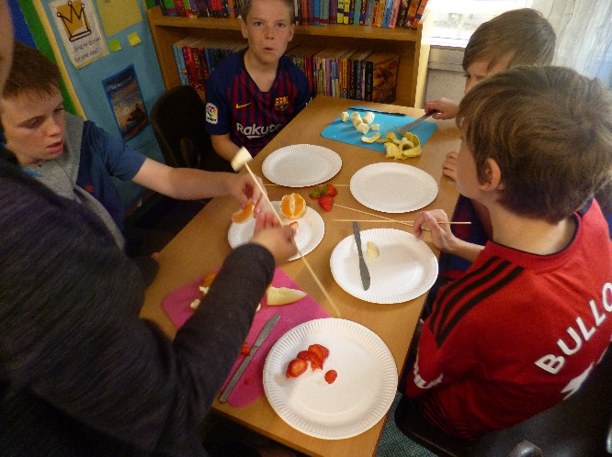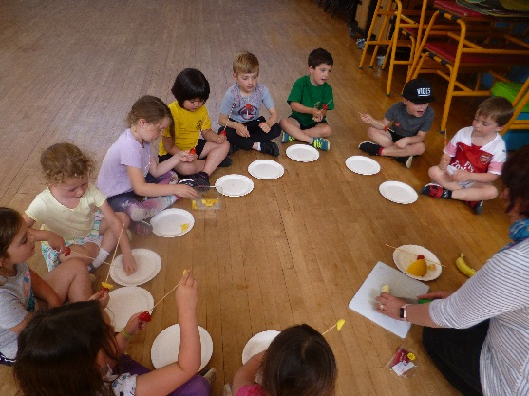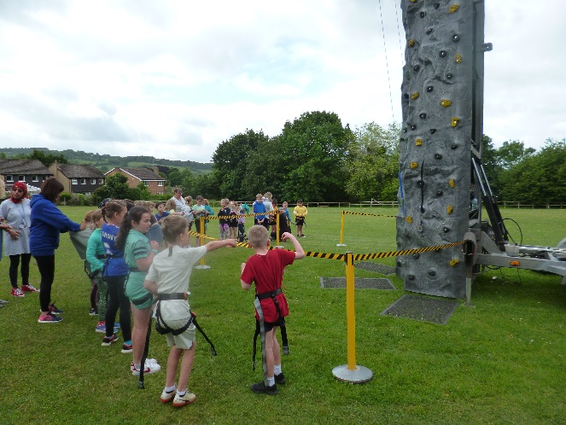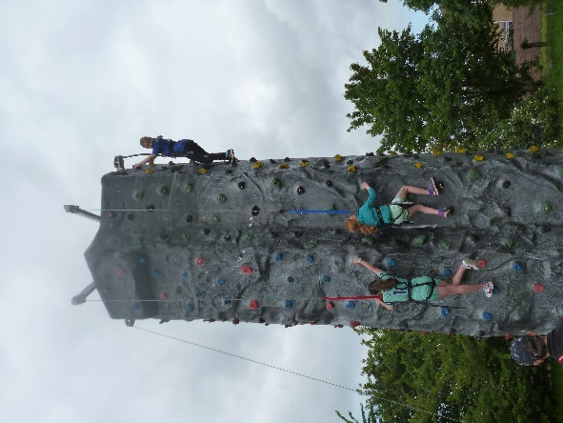

**Climbing wall**

Children from year 1-6 tried out climbing on the mobile climbing wall. Children were able to have several attempts and lots of children managed to reach the top of the wall.

**Fruit Kebabs**

All children from the school were able to make a fruit kebab. They were able to use the knives to slice the fruit, trying some new healthy alternative snacks.

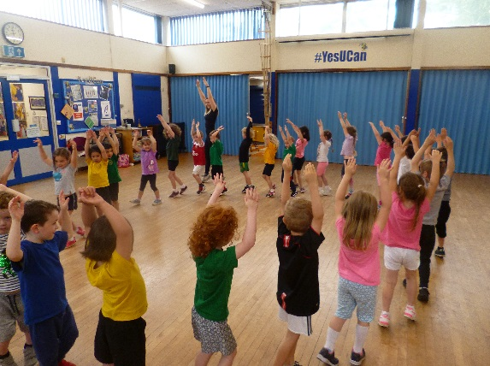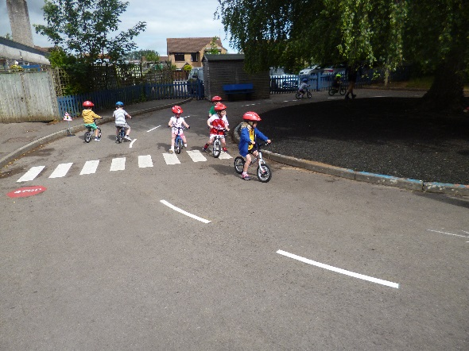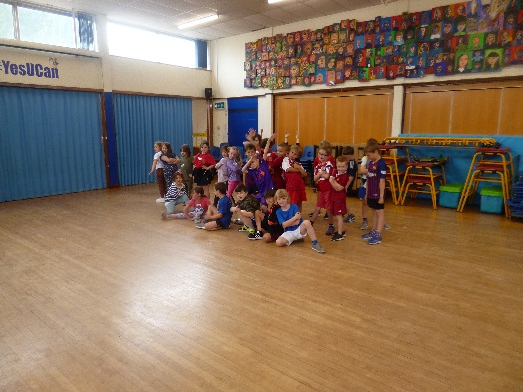

**Dance**

KS1 had a dance workshop in the morning from a local dance teacher. The sessions were linked to their class topics.

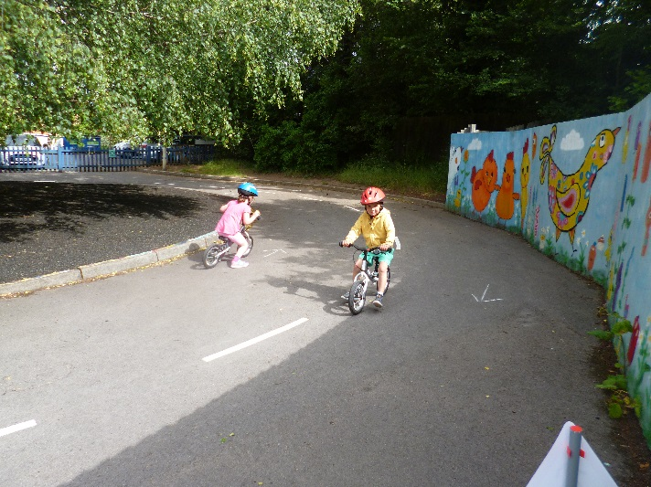

**Balance Bikes**

Reception spent part of the morning on the balance bikes, using the new playground markings to learn about road safety. Some children were able to progress to their first try on pedal bikes.

**Cotteswold Dairy**

In the afternoon Cotteswold dairy visited to talk about the importance of protein in children’s diets. They also looked at the amount of sugar in different drinks. Children then turned milk into butter and took this home.

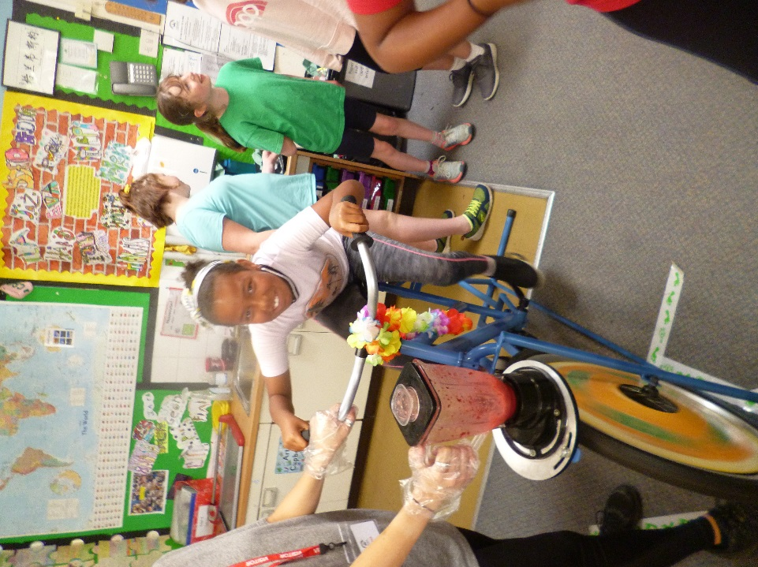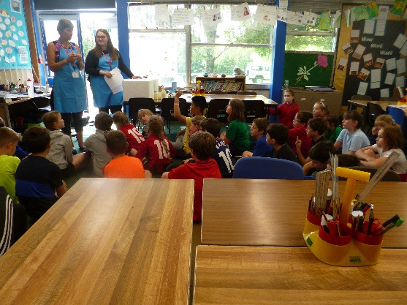

**Smoothie Bike**

Y1 – Y6 were able to make their own fruit smoothie on the smoothie bikes, learning about the different fruits that they had put in them, before designing their own smoothie poster.