ENGLISH
- Reading comprehension
- Spellings
- Punctuation and grammar
- Adventure stories (Letters from the Lighthouse).
- Poetry
- Vocabulary
- Characterisation
- Drama

ART
- World War Two caricatures
- Portraits and self portraits
MATHS
- Numbers and the number system
- Mental and written calculation – four operations
- Investigating properties of shapes, including angles and nets
- Visualising and constructing
- Algebra
- Fractions, decimals and percentages

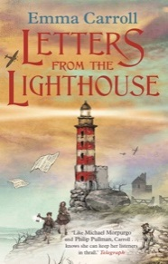

ICT
- E-safety including cyberbullying
- Programming
RE
- Creation and science: conflicting or complementary?

Topic
HISTORY – WORLD WAR TWO
- Timeline of the war
- The Battle of Britain
- Evacuees
- Rationing
- The Blitz

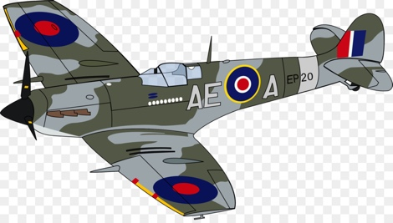
Year 6 Topic overview

SCIENCE
- Functions of heart, blood vessels and blood
- Dissection
- Transport of nutrients and water within humans
- Impact of exercise, diet, drugs and lifestyle

MUSIC
- WW2 singing
PSHE
- Philosophy for Children
- Friendships

PE
- Football
- Team games
- Gymnastics

