**MATHS**

* Numbers and the number system
* Counting and comparing
* Calculation – four rules
* Investigating properties of shapes
* Visualising and constructing
* Fractions decimals and percentages

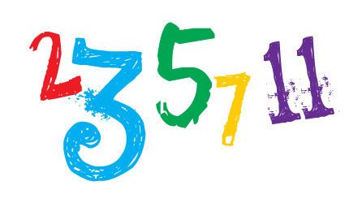

**HISTORY –The Battle of Britain**

* Timeline of the war
* The Battle of Britain
* Evacuees
* The Blitz
* Propaganda

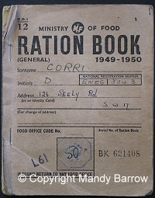

**ENGLISH**

* Biography
* Imagery through classic narrative poetry
* Non-chronological texts
* Diaries
* Class Novel ‘Letters from the Lighthouse’ by Emma Carroll



**HEALTHY LIVING**

* **Functions of heart, blood vessels and blood**
* **Dissection demonstration**
* **Transport of nutrients and water within humans**
* **Impact of exercise, diet, drugs and lifestyle**

**YEAR 5**

|  |
| --- |
| **RE**  What does it mean for  Christians to believe that  God is holy and loving? |

**ART** 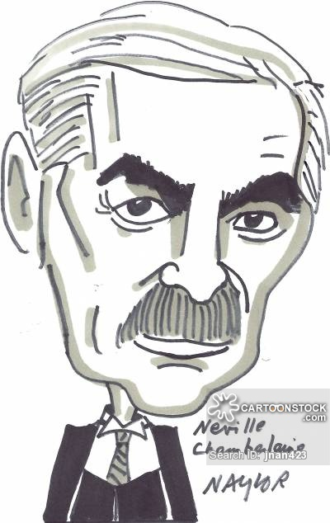

WW2 portraits

DT - sewing