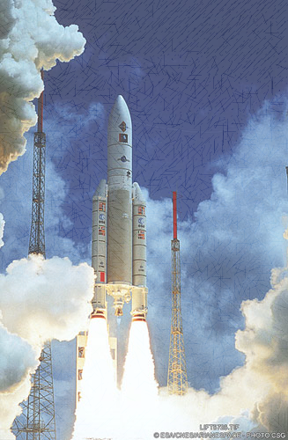

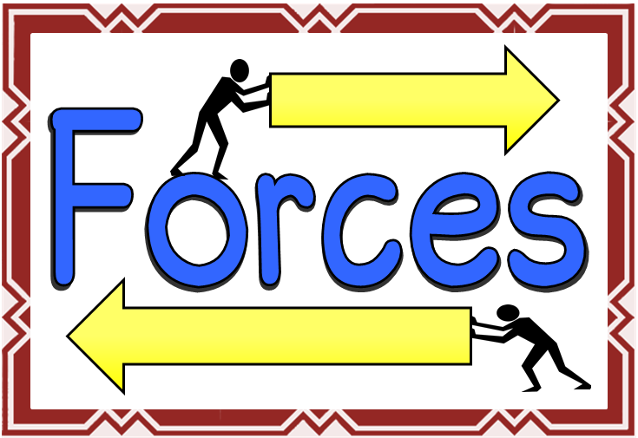

**ENGLISH**

Word classes

Newspaper reports

Describing characters and setting

Spelling and Grammar

Persuasion/arguments

**MATHS**

Time and measures

Area and perimeter

Algebra

Fractions, decimals and Percentages

Measuring data

**THE EARTH AND SPACE**

* Our solar system
* Heliocentric and geocentric models
* Day and night
* Measuring forces
* Balanced and unbalanced forces
* Friction
* Air-resistance
* Water resistance
* Measuring forces
* Balanced and unbalanced forces
* Friction
* Air-resistance
* Water resistance
* Earth’s tilt and seasons
* The moon

PE

* Tag rugby
* Netball
* Gymnastics

**Out of this world**

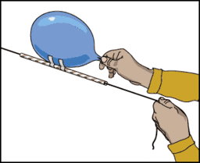

French

Classroom routines

School uniform

Family and descriptions

Art

Study an artist’s work – Peter Thorpe

Space paintings

ICT

* Coding
* Spreadsheets

PSHE/ philosophy for children

* Healthy and unhealthy relationships
* Our mental health
* Bullying

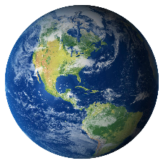

Music

* Study a composer – Holst
* Read musical notation
* Composing

Geography

* The Power of Nature – volcanoes and earthquakes.
* Map work including longitude and latitude.