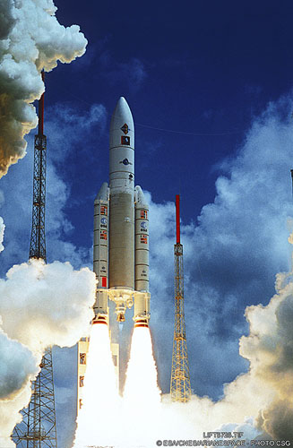
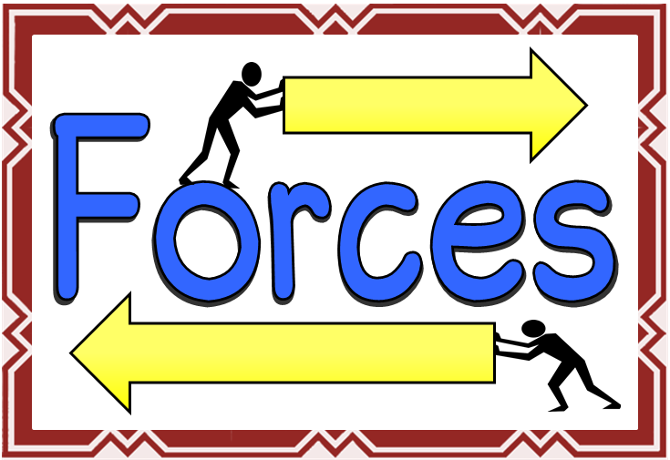

ENGLISH
Explanations Précis
Letters
Stories: character and setting
Class Novel “The Middler by Kirsy Applebaum

MATHS
Fractions – adding and subtracting
Write decimals as fractions
Percentages
Length, capacity, mass and time
Shape

THE EARTH IN SPACE
- Our solar system
- Measuring forces
- Balanced and unbalanced forces
- Friction
- Air-resistance
- Water resistance
- Heliocentric and geocentric models
- Day and night
- Earth’s tilt and seasons
- The moon
BLAST-OFF
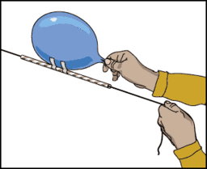
Art/DT
Peter Thorpe – space art study
Moon paintings using colour mixing
Music
Holst – The Planets
Space compositions

FRENCH
Buildings, directions, hobbies, food and Easter in France.
PE
Feet First Dance Festival
Superstars sports – invasion games
HISTORY/GEOGRAPHY
Planet Earth – mapping, longitude and latitude, natural phenomena such as volcanoes, earthquakes and wild weather
ICT
Coding, spreadsheets using excel and powerpoints

