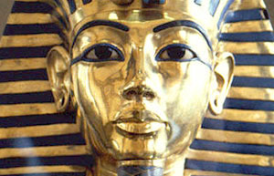

**Maths**

* Number and place value
* Shape
* Checking and estimating
* Multiplication and division
* Converting time and solving time problems
* Units of measure

**French**

* Revision of basic phrases, foods, colours, numbers, days of the week and weather
* Responding to simple sentences
* Classroom commands
* Where we live

**Art**

* Using different media – chalks, watercolours, clay
* Sketching
* Making and testing a model of a shaduf

**Science**

* Comparing and grouping materials by their properties
* Reversible and irreversible changes
* Investigating absorbency
* Investigating how to separate mixtures and solutions

The Mystery

of the Nile

**Geography/History**

* Where is Egypt?
* Why was the Nile so important?
* How and why were pyramids built?
* Who was Tutankhamun and how was he discovered?
* Ancient Egyptian beliefs

**Literacy**

* Guided reading and reading comprehensions
* Spelling and grammar
* Adventure stories
* Diary writing
* Formal and informal letters
* Poetry

**ICT**

* E-safety
* Research
* Hyperlinked Powerpoints

**PE**

* No contact games
* Yoga
* Hockey
* Netball

**PSHE**

* Class rules
* Friendships
* Philosophy for children – class debates
* Random acts of kindness
* Mindfulness