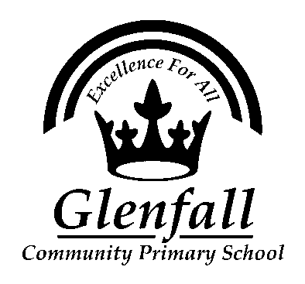

Glenfall Community Primary School
Admissions Policy

Date Agreed by Governors February 2021

Date of Review February 2024

This policy should be read in conjunction with:
- Safeguarding Policy
- Anti-bullying Policy
- Behaviour Policy
- Early Help Offer
- Disability Discrimination Act (Equal Opportunities)
- Pupil Premium Policy
- First Aid Policy

School Admissions Statement
Glenfall Community Primary School adopts the Local Authority Admissions Policy.
To view the Admission Policy for our school please click here<https://www.gloucestershire.gov.uk/education-and-learning/school-admissions-scheme-criteria-and-protocol/>
Please then click on the link to the Determined Admission Criteria and Scheme for the required year, and our Admission Policy is shown under GCC Admission Arrangements.
If you have any queries, please feel free to contact me at SchoolAdmissionPolicy@gloucestershire.gov.uk<mailto:SchoolAdmissionPolicy@gloucestershire.gov.uk>
The local authority website will also advise on appeals.

Starting school in Reception (Foundation Stage)
If you wish your child to start school at Glenfall you will need to follow the procedures detailed on the Gloucestershire County Council website: http://www.gloucestershire.gov.uk/education-and-learning/school-admissions/apply-for-a-primary-or-infant-school-place/
There is an online application system that is usually open from mid-November to mid-January with places being offered in April before the new school year. Exact dates will vary so please follow the information given on the website.

In Year Admissions
‘In Year’ admissions refer to children starting at Glenfall at a time other than the start of their Reception year (foundation stage).
Information about this process is available from http://www.gloucestershire.gov.uk/education-and-learning/school-admissions/applying-for-a-school-place-during-the-school-year/
If you are interested in your child moving to Glenfall, please first contact the school office on 01242 234055 to enquire if we have places available in the year group that you are seeking.
If we have places available and you wish to apply for your child, you will need to complete an application form available from the county council’s website (see above) and then email it to us on admin@glenfall.gloucs.sch.uk.

