

Glenfall Community Primary School

Complaints Procedure

Date Agreed by Governors July 2021

Date of Review July 2024

Glenfall Primary School
Policy and Procedure for Complaints

1. Introduction

All schools have a duty to have a complaints procedure and to publicise it to parents and pupils.
This procedure for Glenfall Primary School has been approved by the Headteacher and Chair of Governors in consultation with governors, including parent governors, and staff.

Complaints procedures should not be used for appeals and referrals that fall under other procedures and legislation and which are covered by other guidance, including:

- Admissions
- Exclusions
- Special Educational Needs
- Staff Grievances
- Child Protection
- Whistleblowing
- Home School Agreement

2. Raising a concern or complaint

Informal Stage (Stage 1)

Parents can raise concerns by contacting their child’s class teacher or the Headteacher. This should be by letter, or by telephone or email or in person by appointment. Many concerns can be resolved by simple clarification or the provision of information and it is anticipated that most complaints will be resolved at this informal stage. If your complaint remains unresolved, it should be raised with the Headteacher [or to the Chair of Governors, if the complaint is about the Headteacher] to investigate and respond to you.

In the case of serious concerns it may be appropriate to address them directly to the Headteacher [or to the Chair of Governors, if the complaint is about the Headteacher].

The school will endeavour to give a prompt feedback in response to any complaint received.
If you are uncertain about who to contact, please seek advice from the school office or the Clerk to the governing body.

Formal Stage (Stage 2)
If your concern or complaint is not resolved at the informal stage you must put the complaint in writing and pass it to the Headteacher, [or to the Clerk to the governing body, for the attention of the Chair, if the complaint is about the Headteacher] who will be responsible for ensuring that it is investigated appropriately.

You should include details which might assist the investigation, such as names of potential witnesses, dates and times of events, and copies of relevant documents. You may choose to use the Formal Complaints Form in Appendix A.

It is very important that you include a clear statement of the actions that you would like the school to take to resolve your concern. Without this, it is much more difficult to proceed.

Please pass the completed paperwork, in a sealed envelope to the Headteacher or to the Clerk to the governing body, as appropriate.

The Headteacher [or Chair] may invite you to a meeting to clarify your concerns and to seek an informal resolution. If you accept that invitation, you may be accompanied, by a friend/advocate (not a member of the legal profession or the media) if you wish, to assist you in explaining the nature of your concerns.

It is possible that your complaint will be resolved through a meeting with the Headteacher [or Chair]. If not arrangements will be made for the matter to be fully investigated, using the appropriate procedure. In any case you should learn in writing, usually within 5 working days of the school receiving your formal complaint, how the school intends to proceed. This notification should include an indication of the anticipated timescale; usually within 15 working days.

Any investigation will begin as soon as possible and when it has been concluded, you will be informed in writing of its conclusion.

Stage 3
If the complaint remains unresolved you may refer the complaint to the Chair of Governors. Your complaint will be acknowledged within 5 working days with a full response in writing within 15 working days.

Stage 4
If you are not happy with the response provided by the Headteacher [or Chair to Governors] the complaint can be referred to the governing body for review. Any such request must be made in writing to the Clerk to the governing body, within 10 school days of receiving notice of the outcome, and include a statement specifying any perceived failures to follow the procedure. The procedure described below will be followed.

Review Process
Any review of the process followed by the school or of the investigation of the complaint will be conducted by a panel of 3 members of the governing body. This will usually take place within 15 school days of receipt of your request.

The review will normally be conducted through a consideration of written submissions, but reasonable requests to make oral representations should be considered sympathetically.

The panel will first receive written evidence from the complainant.

The panel will then invite representatives of the school [usually the Headteacher or the Chair of the governing body panel that has considered the matter], as appropriate, to make a response to the complaint.

The panel may also have access to the records kept of the process followed.
You, and the school representative[s], will be informed in writing of the outcome, usually within 5 school days of the panel meeting.

For most complaints the decision of the governors is the last step in the procedure.

The Secretary of State
If you are not satisfied with the response from the governing body you can contact the Secretary of State for Education via the DFE Helpline on 0370 000 2288 5

This procedure is simplified in Appendix B

Annex to Complaints Policy

Policy for dealing with Unreasonably Persistent Complaints, Harassment or Aggression

The Headteacher and staff deal with specific complaints as part of their day-to-day management of the school in accordance with the School’s Complaints Procedure.
The majority of complaints are handled in an informal manner and are resolved quickly, sensitively and to the satisfaction of the complainant. The school is extremely committed to promoting positive relationships with all members of the school community, regardless of age, sex, religion, ability or culture and it welcomes the opportunity to address and resolve issues that may arise.

However, there are rare occasions when complainants behave in an unreasonable manner when raising and/or pursuing concerns. The consequences are that the actions of the complainants begin to impact negatively on the day-to-day running of the school and directly or indirectly the overall well-being of the children or staff in the school. In these exceptional circumstances the school may take action in accordance with this policy.

1. What does the school expect of any person wishing to raise a concern?
The school expects anyone who wishes to raise concerns with the school to:
• treat all members of the school community with courtesy and respect;
• respect the needs of pupils and staff within the school;
• avoid the use of violence, or threats of violence, towards people or property;
• avoid any aggression or verbal abuse;
• recognise the time constraints under which members of staff in schools work and allow
the school a reasonable time to respond to a complaint;
• recognise that resolving a specific problem can sometimes take time:
• follow the school’s complaints procedure (and for staff members to follow the appropriate
internal staff procedure).

2. What do we mean by 'unreasonably persistent complainants’?
For the purpose of this policy, an unreasonably persistent complainant may be anyone who engages in unreasonable behaviour when making a complaint. This will include persons who pursue complaints in an unreasonable manner.

Unreasonable behaviour may include the following (not an exhaustive list):

• actions which are obsessive, persistent, harassing, prolific, repetitious;
• prolific correspondence or excessive e-mail or telephone contact about a concern or
complaint;
• uses Freedom of Information requests excessively and unreasonably;
• an insistence upon pursuing unsubstantial complaints and/or unrealistic or unreasonable
outcomes;
• an insistence upon pursuing complaints in an unreasonable manner;
• an insistence on only dealing with the Headteacher on all occasions irrespective of the
issue and the level of delegation in the school to deal with such matters;
• an insistence upon repeatedly pursuing a complaint when the outcome is not satisfactory
to the complainant but cannot be changed, for example, if the desired outcome is beyond
the remit of the school because it is unlawful.
• making what appears to be groundless complaints about staff dealing with the complaint
and seeking to have them replaced.
• abusive or threatening behaviour or language towards school staff.
• failing to specify grounds of the complaint, despite offers of assistance from the school.

3. What is harassment?
We regard harassment as including the unreasonable pursuit of issues or complaints, particularly if the matter appears to be pursued in a way intended to cause personal distress, rather than to seek a resolution.

Behaviour may fall within the scope of this policy if:

• it appears to be deliberately targeted at one or more members of school staff or others,
without good cause;
• the way in which a complaint or other issue is pursued (as opposed to the complaint
itself) causes undue distress to school staff or others;
• it has an unjustifiably significant and disproportionate adverse effect on the school
community.

4. School’s responses to unreasonably persistent complaints or harassment
This policy is intended to be used in conjunction with the school’s complaints procedure. Taken together, these documents set out how we will always seek to work with parents, carers and others with a legitimate complaint to resolve a difficulty.

However, in cases of unreasonably persistent complaints or harassment, the school may take some or all of the following steps, as appropriate:

• inform the complainant informally that his/her behaviour is now considered by the school
to be unreasonable or unacceptable, and request a changed approach;
• inform the complainant in writing that the school considers his/her behaviour to fall under
the terms of the Unreasonably Persistent Complaints/ Harassment Policy;

• require any future meetings with a member of staff to be conducted with a second person
present. In the interests of all parties, notes of these meetings may be taken;
• inform the complainant that, except in emergencies, the school will respond only to
written communication and that these may be required to be channelled through a third
party chosen by the school, for example the Local Authority or County Solicitor;
• inform the complainant that, with the exception of urgent communication regarding their
child in school, the school will respond to their correspondence on a 6 weekly basis only;
• take legal advice on pursing a case under Anti-Harassment legislation.
Legitimate new complaints will always be considered in an appropriate time frame, even if the
person making them is (or has been) subject to the Unreasonably Persistent Complaints/
Harassment Policy. The school nevertheless reserves the right not to respond to
communications from individuals whose conduct falls within the scope of this policy.

5. Physical or verbal aggression
The governing body will not tolerate any form of physical or verbal aggression against
members of the school community. If there is evidence of any such aggression the school
may:

• barring the individual from entering the school site, with immediate effect;
• request an Anti-Social Behaviour Order (ASBO);
• take legal advice on pursing a case under Anti-Harassment legislation;
• call the police to remove the individual from the premises, under powers provided by the
Education Act 1996.

Barring from the School Premises

Although fulfilling a public function, schools are private places. The public has no
automatic right of entry. Schools will therefore act to ensure they remain a safe place
for pupils, staff and other members of their community.

If a parent’s behaviour is a cause for concern, a school can ask him/her to leave
school premises. In serious cases, the headteacher or the local authority can notify
them in writing that their implied licence to be on school premises has been
temporarily revoked subject to any representations that the parent may wish to
make. Schools should always give the parent the opportunity to formally express
their views on the decision to bar in writing.

The decision to bar should then be reviewed, taking into account any representations
made by the parent, and either confirmed or lifted. If the decision is confirmed the
parent should be notified in writing, explaining how long the bar will be in place.

Anyone wishing to complain about being barred can do so, by letter or email, to the
headteacher or Chair of Governors. However, complaints about barring cannot be
escalated to the Department for Education. Once the school’s own complaints
procedure has been completed, the only remaining avenue of appeal is through the
Courts; independent legal advice must therefore be sought.

6. Right of appeal
6. Right of appeal
All persons who are notified by the school that they are being dealt with under this procedure have the right of appeal. Appeals must be addressed to the Chair of Governors under confidential cover, care of the school. The Chair of Governors will consider each appeal on its merits, consulting with the Headteacher as appropriate. The outcome of the appeal should be notified to the appellant and copied to the Headteacher within 10 working days of receipt.

This policy has been revised by the head teacher in consultation with the staff and governors of the school in September 2020. It will be reviewed in September 2023 unless there is a change in legislation.

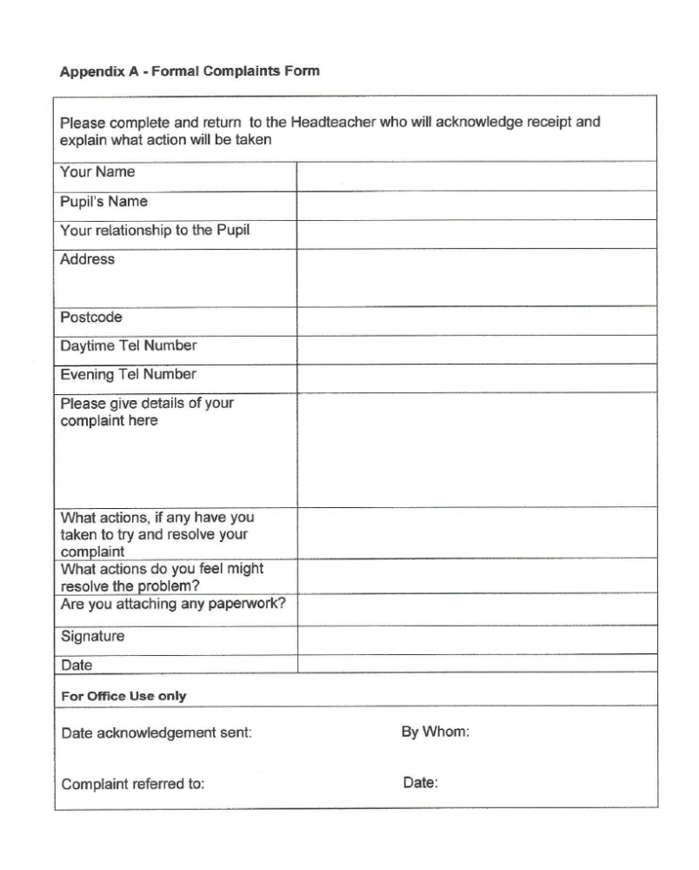


Appendix B

Complaints Procedure

What to do if you have a concern or complaint about Glenfall Primary School

At Glenfall Primary School, we like to be told about how we are doing, whether well or badly. If you have a concern or complaint we always try to deal with it helpfully and reasonably. If we need to, we try to put things right as quickly as possible. If you have a concern or complaint about Glenfall Primary School you need to take it up with the school itself. The local education authority would not usually get involved in a complaint about a school unless the school had completed its own procedures first.

This complaints procedure is for general complaints. The school must follow other procedures for complaints or appeals about the curriculum, special educational needs provision, exclusions and admissions. Staff disciplinary action, child protection issues or criminal investigation will also need to be handled differently. We shall tell you which is the right process when you discuss your concern with us.

The complaints procedure has four stages. You will be told what to do at each stage if you wish to take your complaint further.

 | Stage 1 of the process is informal:
STAGE 1 | If you have a concern about the school, try to talk to someone at the school, preferably the person who is most closely involved. If you get in touch with one of the governors first of all they can give you only general advice. They may need to ask you to take up your concerns with the member of staff best able to help you, or with the headteacher.  Your concern can usually be settled quickly and without fuss by contacting the right person in the school. This could be your child’s teacher, another member of staff or the headteacher.

 | If your concern cannot be sorted out in this way or you are not happy with the way it has been dealt with you should take it to stage 2: The complaint is now formal.
STAGE 2 | You should write to the headteacher who will investigate your complaint. If your complaint is about the headteacher you can complain directly to the chair of governors (see Stage 3).  The school will let you know that it has received your complaint within 5 school days. You will be given the results of the headteacher’s investigation in writing within 15 school days.

 | If your complaint has still not been resolved to your satisfaction you may take it to stage 3:
STAGE 3 | You can complain in writing to the chair of governors care of the school. You should make it clear why you are complaining, who you have already spoken to and what you want to happen as a result of your complaint.  The chair of governors will let you know that he or she has received your complaint within 5 school days and will then investigate it.  You will be told about the outcome of the chair of governors’ investigation in writing within 15 school days.

 | If you are still not satisfied after receiving the chair of governor’s report, you can ask to have your complaint referred to a complaints committee of the governing body at stage 4:
STAGE 4 | You can write to the clerk to the governors care of the school. You should say exactly why you are unhappy with the chair of governors’ findings and ask that a complaints committee be set up to look at the complaint.  The committee will meet between 15 school days after the clerk to the governors receives your letter. You will be told in advance about the process and what will happen at the meeting of the committee. You can attend and bring a relative or friend to support you if you want to. You will be told in writing about the committee’s findings within 5 school days from the date of the meeting.

If you are not satisfied with
the response
INFORMAL PROCEDURE
You have a concern or complaint
If your concern or
complaint is about the
headteacher
If you are not satisfied with the
headteacher’s response
If you are not satisfied with the
chair of governors’ response
If you are not satisfied that your complaint
has been properly dealt with
Stage 3: Complain to the chair of governors in
writing, care of the school.
Your complaint will be acknowledged within 5
school days with a full response within 15
school days.
Stage 4: Write to the clerk of the governing
Body, care of the school, requesting that your
complaint be heard by a complaints committee
of governors.

The complaints committee will meet within
15 school days from receipt of your
letter. The committee’s decision is final and
you will be told of its findings within 5 school
days of the hearing.
Write to the Secretary of State for Education
FORMAL PROCEDURE
Stage 2: Complain to the headCducationbetweensponse within 20F THE COMPLAINT IS AGAINST THE HEAD TEACHERdays of receipt.
verbally or in writing.
Your complaint will be acknowledged within 5
school days with a full written response within
15 school days.
FORMAL PROCEDURE
What you should do
What will happen
Stage 1: Discuss your concerns with the class
teacher or other relevant member of staff
(which may be the headteacher). This will
usually resolve the issue.
The member of staff concerned will deal with
your issues or make sure you have the
information you need if you feel you want to
take the matter further.
Write to the LA

If you are not satisfied with
the response
FURTHER RECOURSE
If the
complaint
was not
properly
dealt with
The LA can only intervene in the day to day running of the school in very specific circumstances, and cannot overturn a properly made and legal decision of the Governing Body.

