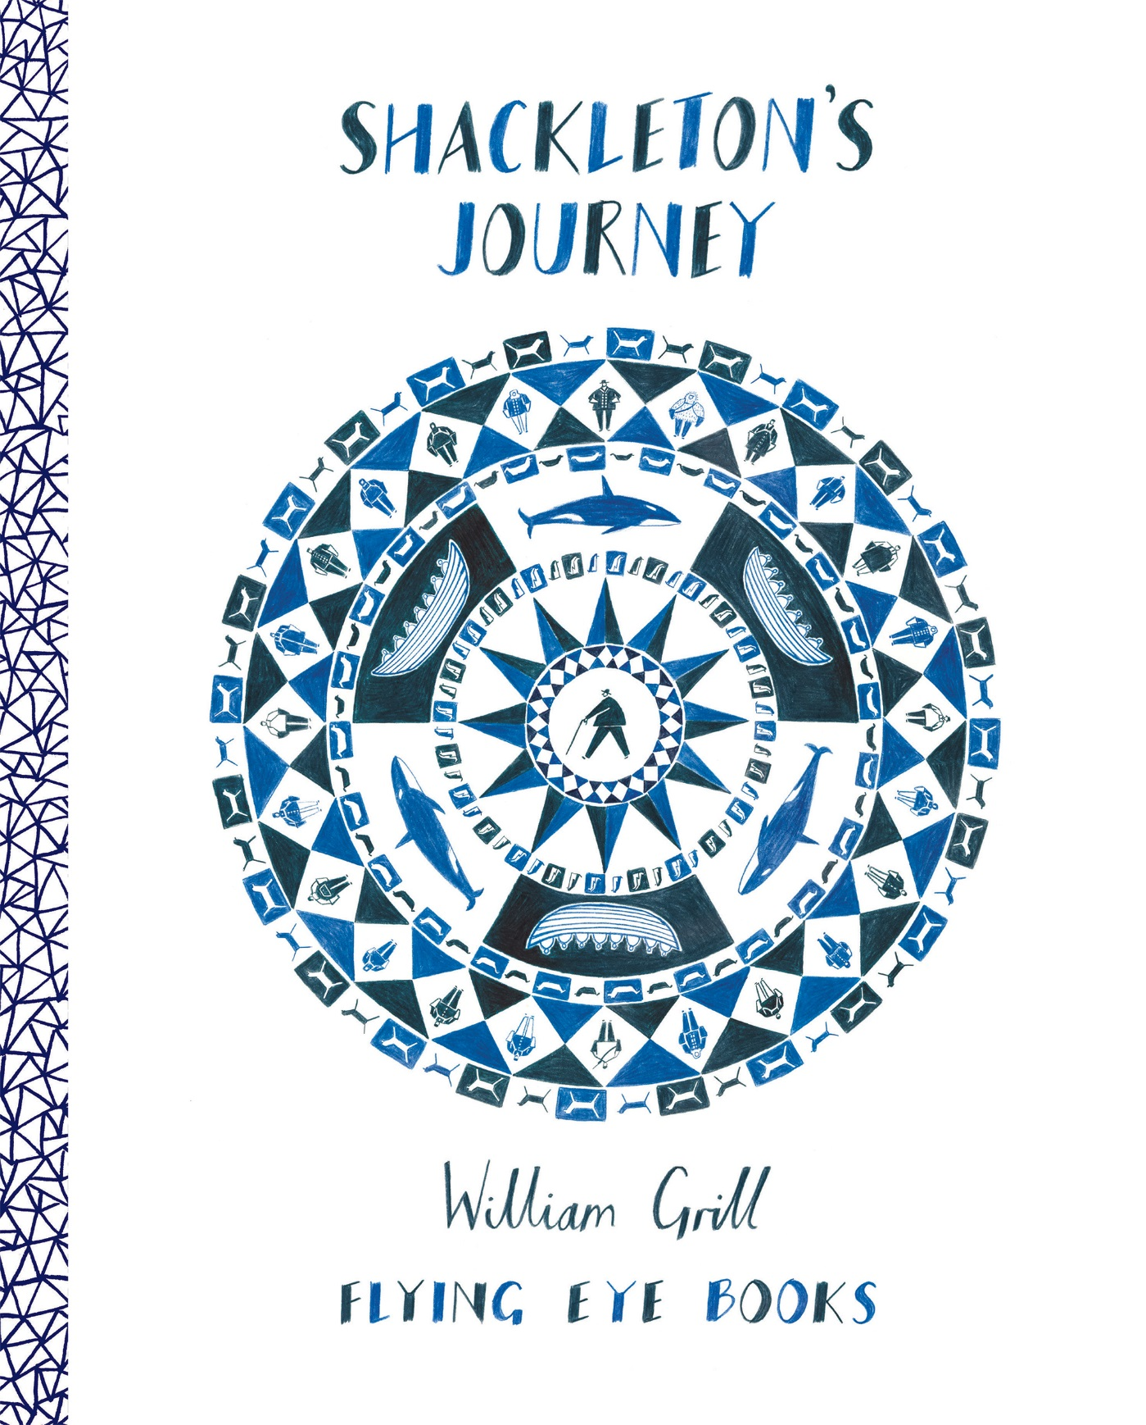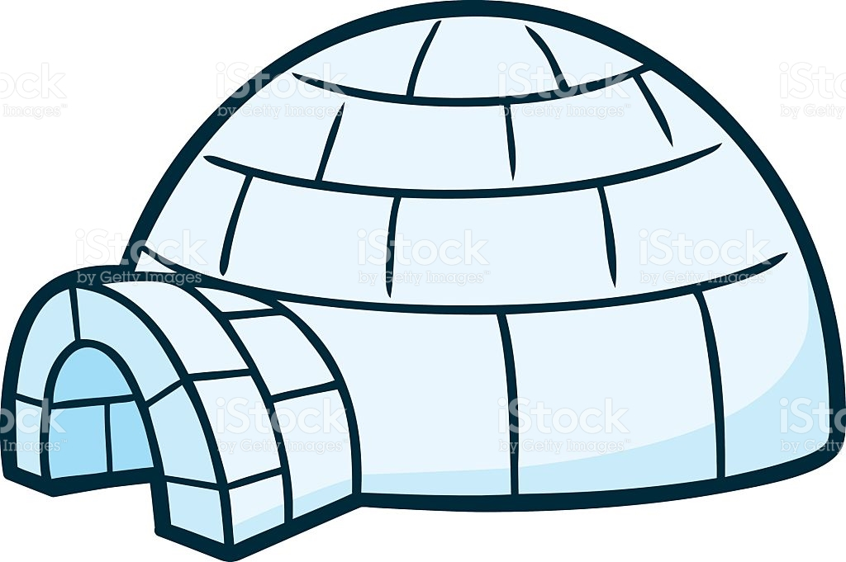

PE

Gymnastics

Swimming

Science

Forces

Electrical circuits, conductors and insulators

Art

Valmar Kurol

Frozen landscapes + colour mixing

French

Days of the week

Months

Music

Weather inspired music

DT

Design a boat, iceberg Easter nests

ICT

Antarctic research, E-safety, PowerPoint skills, wanted posters

PSHE

Keeping safe, feelings and relationships

Geography

Antarctica fact file, grid referencing, compass skills and Antarctic wildlife