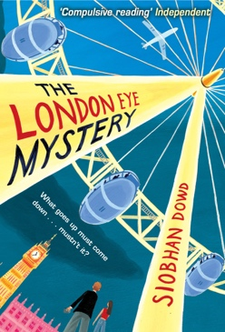

**HISTORY –The Tudors**

* Timeline skills
* Tudor Tewkesbury local   
  study
* Tudor food
* Tudor clothes
* Spanish Armada

**MATHS**

* Calculating fractions, decimals and percentages.
* Mathematical movement
* Presentation of data



**ENGLISH**

* Non-chronological   
  reports
* Mystery stories
* Class Novel ‘The London  
   Eye Mystery’ Siobhan   
  Dowd

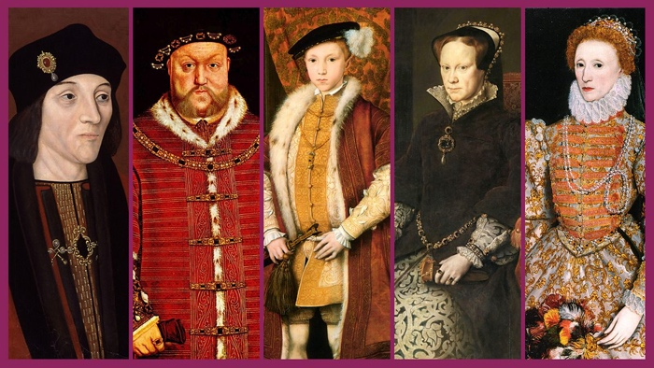



**Life cycles**

* Compare life cycles
* Understand reproduction in plants
* Evaluate findings
* Making observations

**Electricity**

**ART**   
Portraits   
Collages

**PE**Athletics   
Rounders  
Cricket

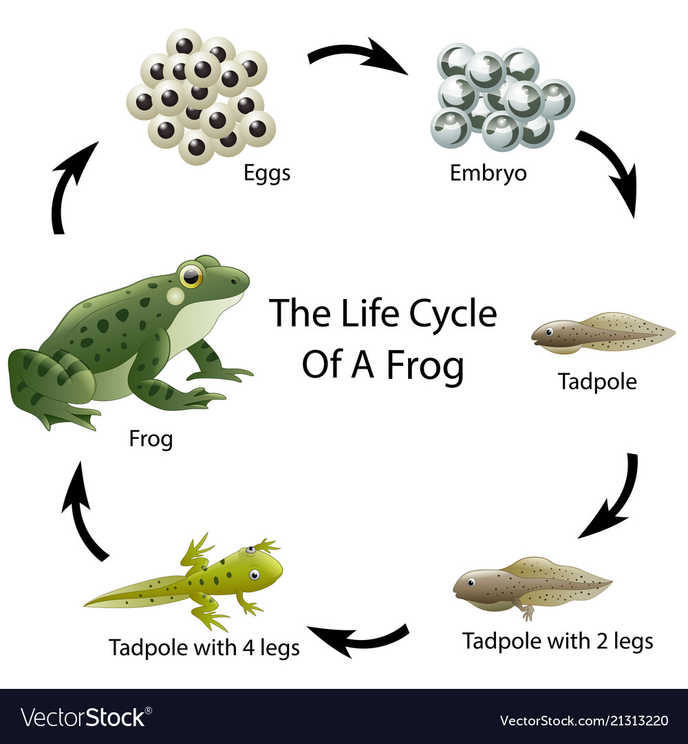

**YEAR 5**

|  |
| --- |
| **RE**  What would Jesus do?  **FRENCH**  The weather |