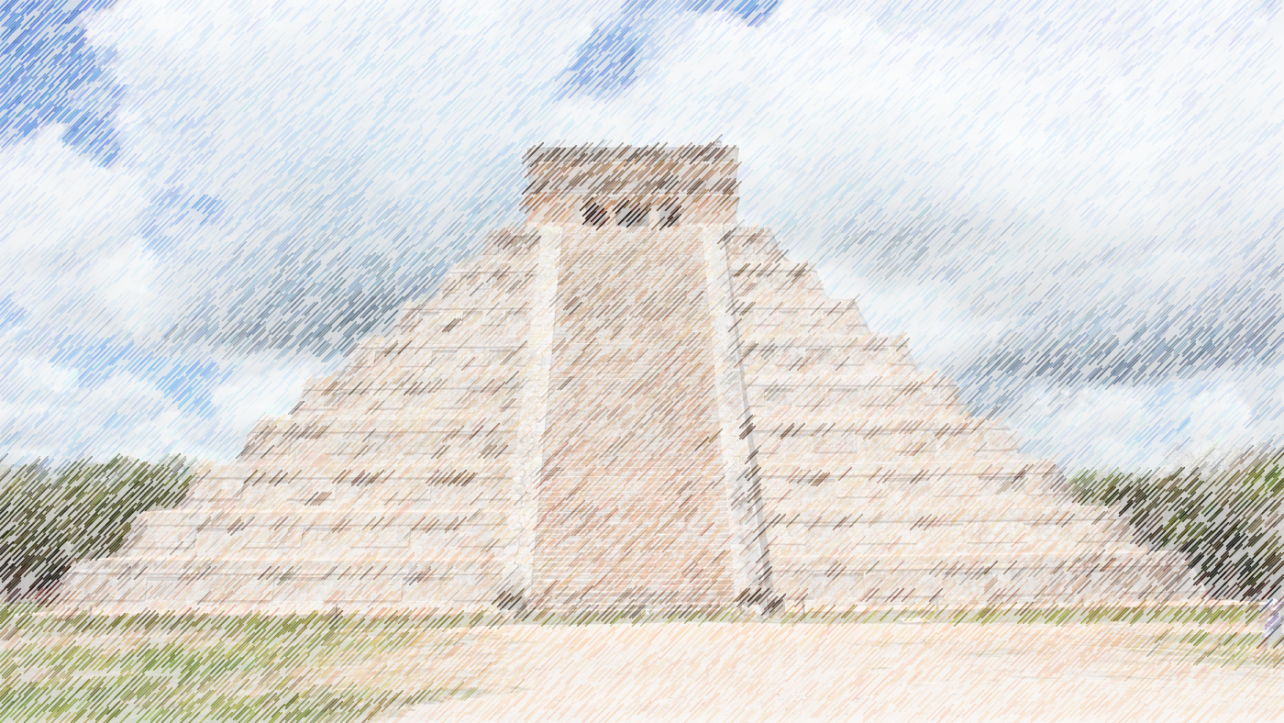

Art

Mayan art – mosaics

Henry Rousseau art work

Music

Sing up: Mayan music

This term Year 3 and 4 will be focusing their studies around the topic of the Mayans. This theme will flow throughout their learning both in school and in their homework.

**A**

**N**

**C**

**I**

**E**

**N**

**T**

**M**

**A**

**Y**

**A**

Year 3 & 4

Autumn term 2022

Topic

Mayan life and South American geography

PE

Football/ Hockey

Swimming (Y3)

Science

Light and sound with links to multiculturalism and RE

ICT

Internet search engines and Scratch coding

DT

Nativity sculpture and South American food

RE

Hinduism Y4