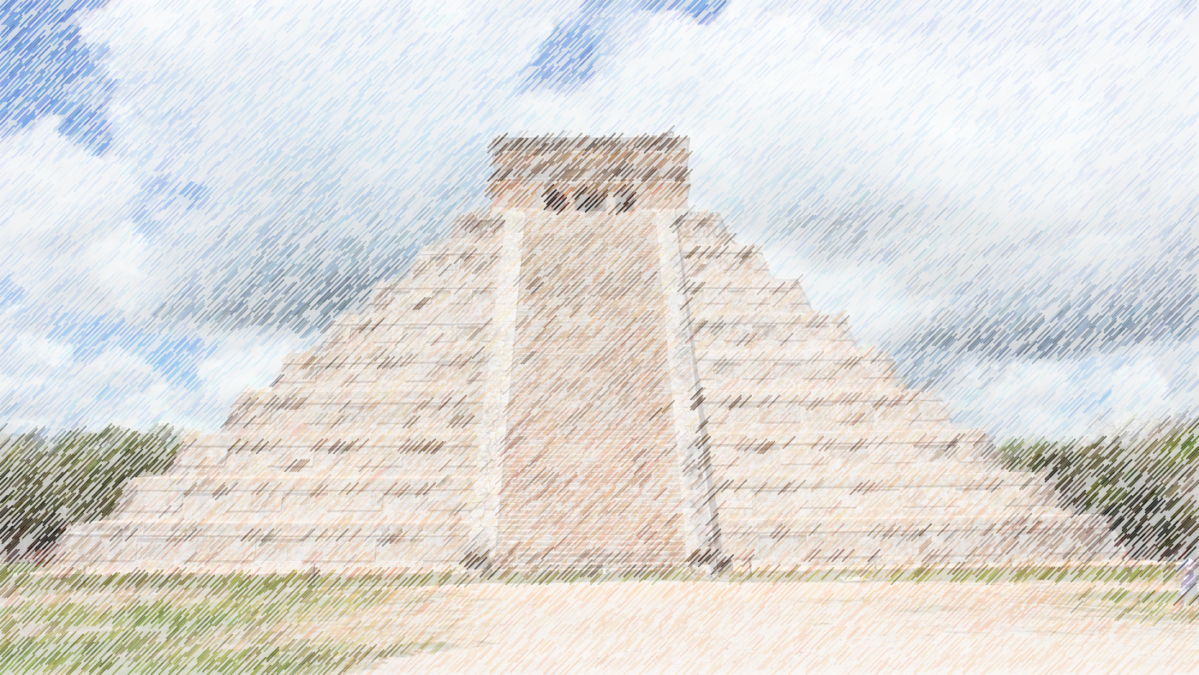

Art

Colour mixing

Clay rainforest animals

Music

Sing up: Mayan music

This term Year 3 and 4 will be focusing their studies around the topic of the Mayans. This theme will flow throughout their learning both in school and in their homework.

**AZTECS**

Year 3 & 4

Autumn term 2022

Topic

Mayan life and South American geography

PE

Football/ Hockey

Swimming (Y3)

Science

Light and sound with links to multiculturalism and RE

ICT

What is a digital device?

Move information between connected devices

DT

Making levers

Seasonality of UK foods

RE

Christianity