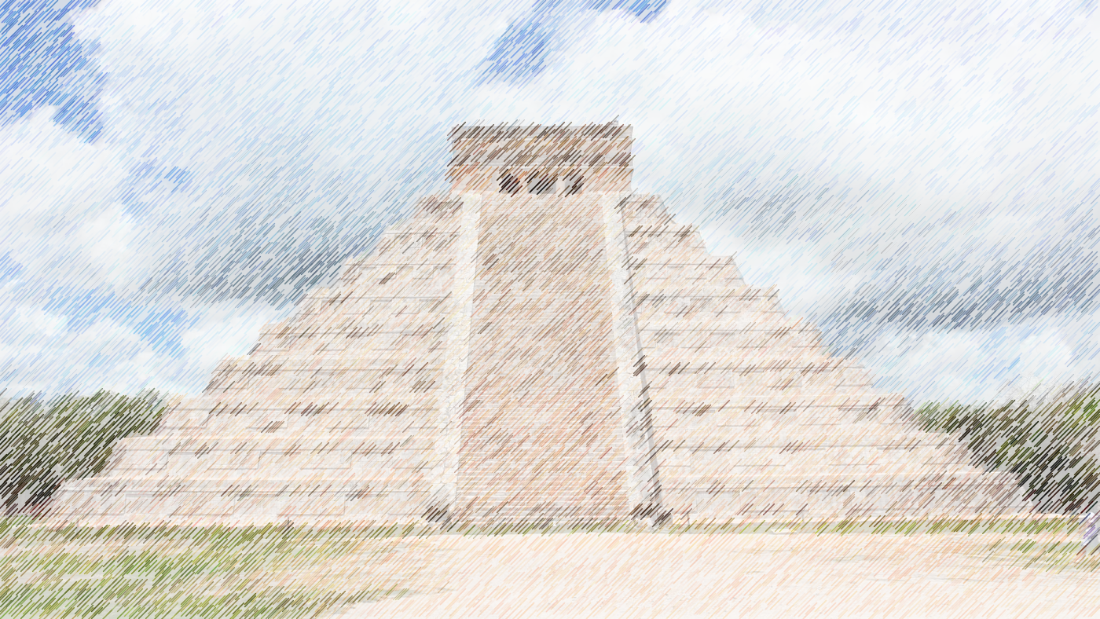
Art
Colour mixing
Clay rainforest animals

Music
Sing up: Mayan music

This term Year 3 and 4 will be focusing their studies around the topic of the Mayans. This theme will flow throughout their learning both in school and in their homework.
AZTECS
Year 3 & 4
Autumn term 2022

Topic
Mayan life and South American geography
PE
Football/ Hockey
Swimming (Y3)

Science
Light and sound with links to multiculturalism and RE
ICT
What is a digital device?
Move information between connected devices
DT
Making levers
Seasonality of UK foods
RE
Christinanity

