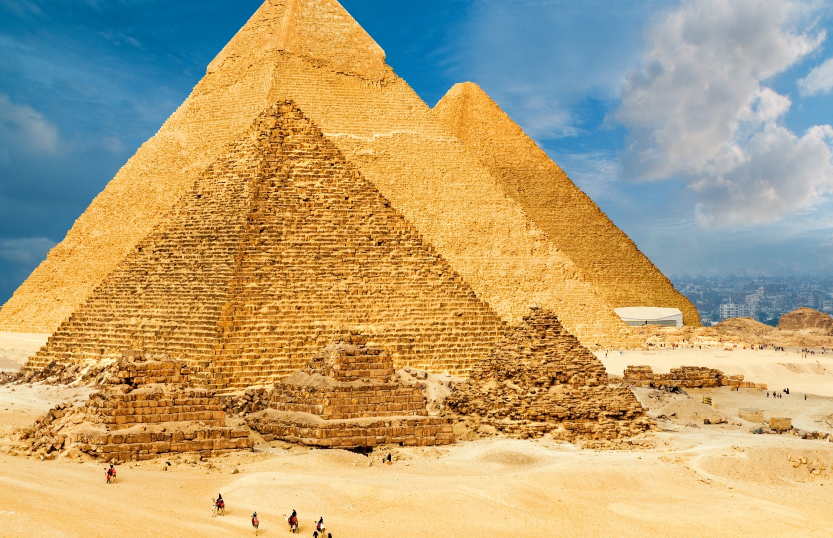
Ancient Egypt
French:
School
Maths:
Numbers and the number system
Data handling
Literacy:
Holes – Louis Sachar
Geography:
Geography of Egypt and The Nile
PE:
Invasion games
Gymnastics
Design Technology:
Resistant materials
woodwork
Computing:
Internet safety
How the internet transfers information
Science:
Materials and states of matter
Reversible and irreversible reactions
History:
Ancient civilisations of the world
Ancient Egypt and The Nile

