**Y 5 AND 6: CLASSIFICATION**

**MICRO-ORGANISMS**

**Beneficial BACTERIA** are useful to us

 

This **harmful bacteria** causes **infection** and makes you poorly.



A **VIRUS** is extremely small and causes illness. The picture below shows influenza, commonly known as **flu**



**Immunisation** builds resistance to harmful micro-organisms and helps protect us from disease. 

**FUNGI** Some microscopic fungi can be harmful e.g. athlete’s foot fungi, some are useful e.g. yeast

**CLASSIFICATION SYSTEMS –** can be used to arrange animals or plants into groups

**INVERTEBRATES** do not have a backbone

**VERTEBRATES** -have an internal skeleton

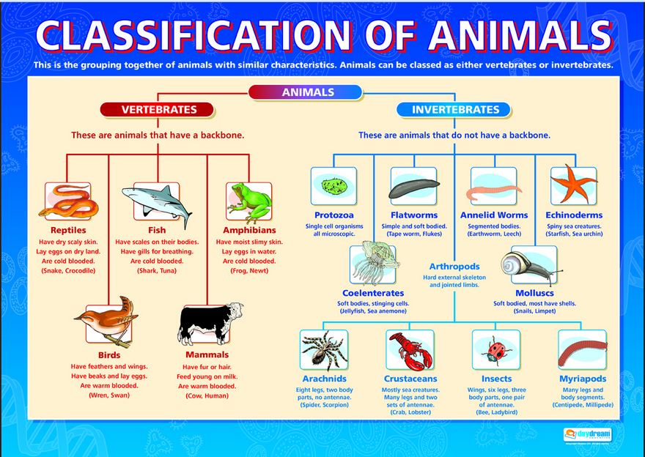

CAN YOU FIND ANY EVIDENCE OF CLASSIFICATION SYSTEMS BEFORE LINNAEUS?

TRY LOOKING AT ARISTOTLE!

**CARL LINNAEUS** (1707-1778) pioneer of classification

