M

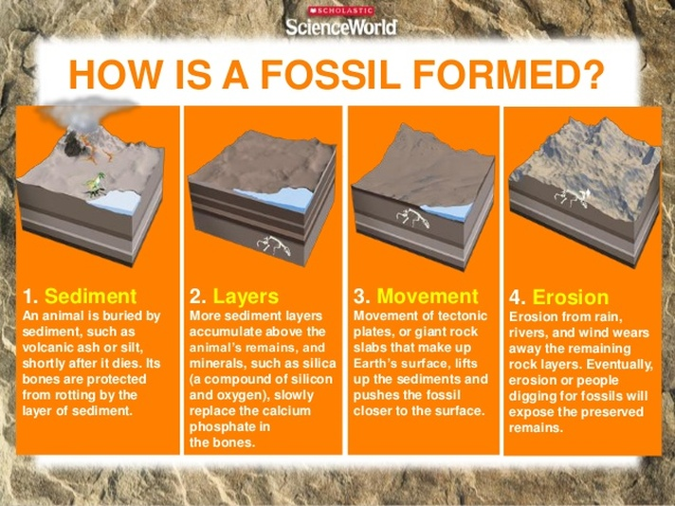

**DARWIN**

In 1859 Darwin published The Origin of the Species.

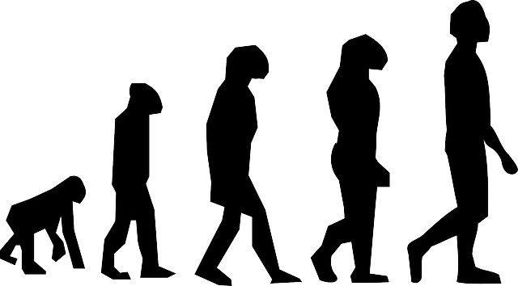

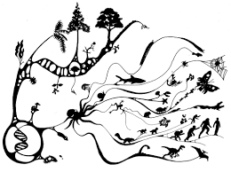

**Adaptation -** small changes as the species evolves, enabling it to change for increased chance of survival.

**Endangered species –** a species that is at risk of becoming extinct

**Extinction –**when the last of a species dies

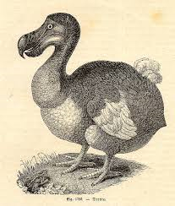

**Fossils** – the remains of once living animals or plants

**Offspring-** an animal’s young

**Natural selection –** process by which populations adapt and evolve

**P**

**Endangered species**

**MARY ANNING 1799-1847**

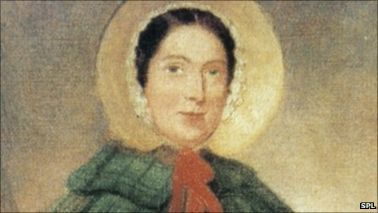

English fossil collector

**GREGOR MENDELL** experimented with peas

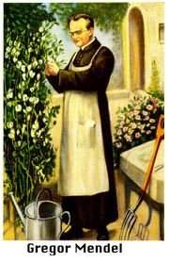

**ALFRED RUSSEL WALLACE**

Worked on a theory of evolution by natural selection

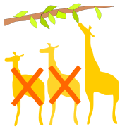

EVOLUTION

WHERE DID IT ALL BEGIN?